github repository: https://github.com/ormadf/PHYS_250

phys_250 has ‘underscore’

Lecture 5

Gauss’s Law:

Net electric flux through the closed surface is equal to the net charge inside the closed surface divided by permittivity of free space



E is the electric field on the closed surface , qin – net charge inside the surface ε0 – permittivity of free space = 8.85 × 10-12 m-3 kg-1 s4 A2

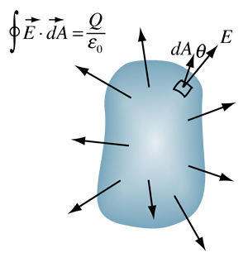

We can use Gauss’s Law to find the electric field for symmetric distributions of charge

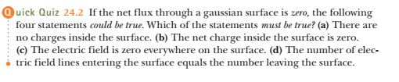

Answers:

a) There are no charges inside the surface

b) The net charge inside the surface is zero

c) The electric field is zero everywhere on the surface

d) the number of electric field lines entering the surface equals the number leaving the surface

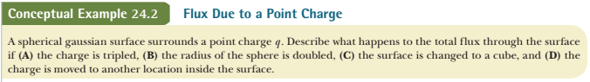

A spherical gaussian surface surrounds a point charge q. Describe what happens to the total flux through the surface if

A) the charge is tripled

B) the radius of the sphere is doubled

C) the surface is changed to a cube

D) the charge is moved to another location inside the surface





We want the expression in integral to be simple

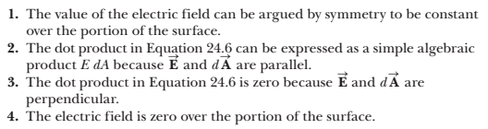

Examples:



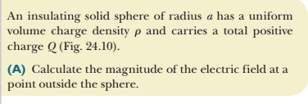

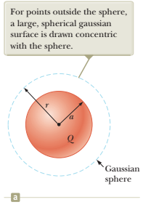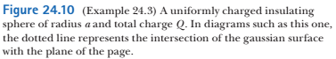

The charge distribution is spherically symmetric

On the gaussian surface (any point) Electric field $\vec{E}$ and surface element $\vec{dA}$ have the same direction

E

dA

Hence,





The magnitude of the Electric field E is the same everywhere on the gaussian surface

Hence,

$\oint{EdA=E \oint{dA=E A}}$

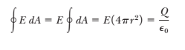

Now we can find E:



the electric field due to a uniformly charged sphere in the region external to the sphere is equivalent to that of a point charge located at the center of the sphere.





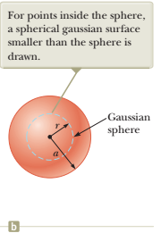





The magnitude of electric field on the gaussian surface is the same everywhere E = const

vectors $\vec{E } and \vec{dA}$ are collinear

Hence:









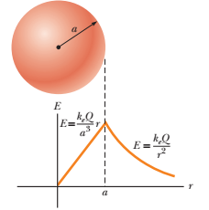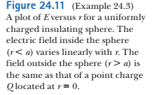





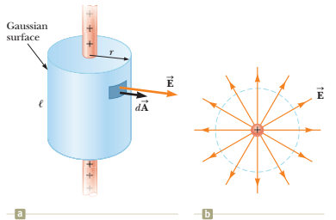

Gauss’s Law:

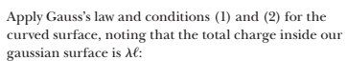

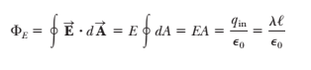

Substitute the area  of the curved surface:



Solve for the magnitude of the electric field:





Find the electric field due to an infinite plane of positive charge with uniform surface charge density σ

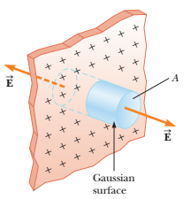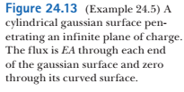

By symmetry, **E** must be perpendicular to the plane at all points. The  
direction of **E** is away from positive charges, indicating that the direction of **E** on one side of the plane must be opposite its direction on the other side as shown in Figure 24.13.

A gaussian surface that reflects the symmetry is a small cylinder whose axis is perpendicular to the plane and whose ends each have an area *A* and are equidistant from the plane

The flux through each end of the cylinder is *EA*; hence, the total flux  
through the entire gaussian surface is just that through the ends:











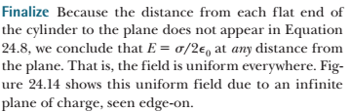

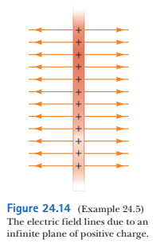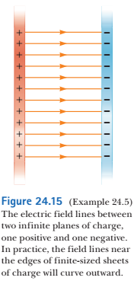





**Electric flux** is proportional to the number of electric field lines that penetrate a surface. If the electric field is  
uniform and makes an angle u with the normal to a surface of area *A*, the electric flux through the surface is



In general, the electric flux through a surface is



**Gauss’s law** says that the net electric flux ΦE  
through any closed gaussian surface is equal to the *net*charge *q*in inside the surface divided by ε0



A conductor in **electrostatic equilibrium** has the following properties:  
**1.** The electric field is zero everywhere inside the conductor, whether  
the conductor is solid or hollow.  
**2.** If the conductor is isolated and carries a charge, the charge  
resides on its surface.  
**3.** The electric field at a point just outside a charged conductor is  
perpendicular to the surface of the conductor and has a magnitude σ/ε0, where σ is the surface charge density at that point.  
**4.** On an irregularly shaped conductor, the surface charge density is  
greatest at locations where the radius of curvature of the surface  
is smallest.

